**Advanced Programming Lab 6**

**Submitted By: Daud Nasir Cheema (209563)**

**Task 1:**

var mc = require("mongodb").MongoClient;

var url = "mongodb://localhost:27017/mydb";

mc.connect(url, { useNewUrlParser:true }, function(err, db){

if(err) throw err;

console.log("Database created");

db.close();

});

**Output:**



**Task 2:**

var mc = require("mongodb").MongoClient;

var url = "mongodb://localhost:27017/";

mc.connect(url, { useNewUrlParser:true }, function(err, db){

if(err) throw err;

var dbo = db.db("mydb");

dbo.createCollection("customers", function(err, res){

if(err) throw err;

console.log("collection created");

db.close();

});

});

**Output:**



**Task 3:**

var mc = require("mongodb").MongoClient;

var url = "mongodb://localhost:27017/";

mc.connect(url, { useNewUrlParser:true }, function(err, db){

if(err) throw err;

var dbo = db.db("mydb");

var val={ name:"daud", address:"sargodha"};

dbo.collection("customers").insertOne(val, function(err, res){

if(err) throw err;

console.log("1 document inserted");

db.close();

});

});

**Output:**



**Task 4:**

var mc = require("mongodb").MongoClient;

var url = "mongodb://localhost:27017/";

mc.connect(url, { useNewUrlParser:true }, function(err, db){

if(err) throw err;

var dbo = db.db("mydb");

var val=[{ name:"amna", address:"sargodha"},

{ name:"abd", address:"sargodha"},

{ name:"hashmi", address: "fslb"}

];

dbo.collection("customers").insertMany(val, function(err, res){

if(err) throw err;

console.log("documents inserted: "+res.insertedCount);

db.close();

});

});

**Output:**



**Task 5:**

var mc = require("mongodb").MongoClient;

var url = "mongodb://localhost:27017/";

mc.connect(url, { useNewUrlParser:true }, function(err, db){

if(err) throw err;

var dbo = db.db("mydb");

var val = [{ _id: 1, name: 'lays'},

{ _id: 2, name: 'coke'},

{ _id: 3, name: 'milk'}

];

dbo.collection("products").insertMany(val, function(err, res){

if(err) throw err;

console.log("documents inserted: "+res.insertedCount);

db.close();

});

});

**Output:**



**Task 6:**

var mc = require("mongodb").MongoClient;

var url = "mongodb://localhost:27017/";

mc.connect(url, { useNewUrlParser:true }, function(err, db){

if(err) throw err;

var dbo = db.db("mydb");

dbo.collection("customers").findOne({}, function(err, result){

if(err) throw err;

console.log(result);

db.close();

});

});

**Output:**

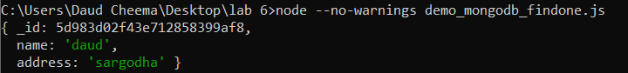

**Task 7:**

var mc = require("mongodb").MongoClient;

var url = "mongodb://localhost:27017/";

mc.connect(url, { useNewUrlParser:true }, function(err, db){

if(err) throw err;

var dbo = db.db("mydb");

dbo.collection("customers").find({}, { projection: {_id : 0, name:1, address:1}}).toArray(function(err, result){

if(err) throw err;

console.log(result);

db.close();

});

});

**Output:**

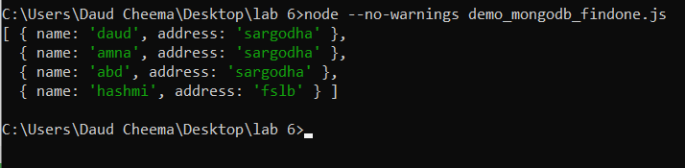

**Task 8:**

var mc = require("mongodb").MongoClient;

var url = "mongodb://localhost:27017/";

mc.connect(url, { useNewUrlParser:true }, function(err, db){

if(err) throw err;

var dbo = db.db("mydb");

var query = {address:"sargodha"}

dbo.collection("customers").find(query, { projection: {_id : 0, name:1, address:1}}).toArray(function(err, result){

if(err) throw err;

console.log(result);

db.close();

});

});

**Output:**

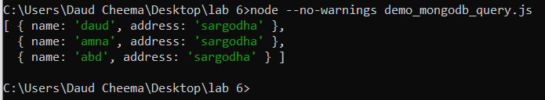

**Task 9:**

var mc = require("mongodb").MongoClient;

var url = "mongodb://localhost:27017/";

mc.connect(url, { useNewUrlParser:true }, function(err, db){

if(err) throw err;

var dbo = db.db("mydb");

var query = {address:"sargodha"};

var mysort = {name:1};

dbo.collection("customers").find(query, { projection: {_id : 0, name:1, address:1}}).sort(mysort).toArray(function(err, result){

if(err) throw err;

console.log(result);

db.close();

});

});

**Output:**

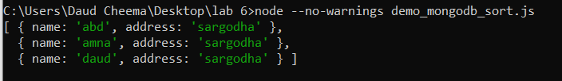

**Task 10:**

var mc = require("mongodb").MongoClient;

var url = "mongodb://localhost:27017/";

mc.connect(url, { useNewUrlParser:true }, function(err, db){

if(err) throw err;

var dbo = db.db("mydb");

var query = {address:"fslb"};

var mysort = {name:1};

dbo.collection("customers").deleteOne(query, function(err, obj){

if(err) throw err;

console.log("1 doc deleted");

console.log(obj.result.n);

db.close();

});

});

**Output:**

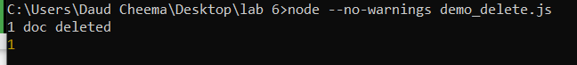

**Task 11:**

var mc = require("mongodb").MongoClient;

var url = "mongodb://localhost:27017/";

mc.connect(url, { useNewUrlParser:true }, function(err, db){

if(err) throw err;

var dbo = db.db("mydb");

var query = {address:/^o/};

var mysort = {name:1};

dbo.collection("customers").deleteMany(query, function(err, obj){

if(err) throw err;

console.log("doc deleted: ", obj.result.n);

console.log(obj.result);

db.close();

});

});

**Output:**

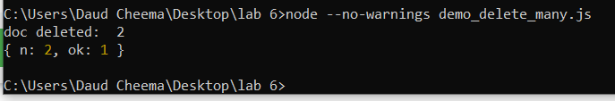

**Task 12 (performed after performing all other tasks):**

var mc = require("mongodb").MongoClient;

var url = "mongodb://localhost:27017/";

mc.connect(url, { useNewUrlParser:true }, function(err, db){

if(err) throw err;

var dbo = db.db("mydb");

var query = {address:"india"};

var newVal = {$set:{name:"mickey", address:"canyon123"}};

dbo.collection("products").drop(function(err,delOk) {

if (err) throw err;

console.log("collection dropped");

console.log(delOk);

db.close();

});

});

**Output:**

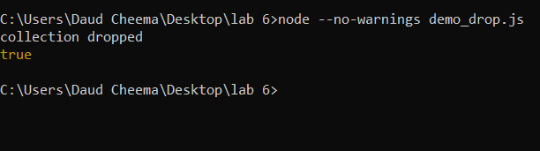

**Task 13:**

var mc = require("mongodb").MongoClient;

var url = "mongodb://localhost:27017/";

mc.connect(url, { useNewUrlParser:true }, function(err, db){

if(err) throw err;

var dbo = db.db("mydb");

var query = {address:"india"};

var newVal = {$set:{name:"mickey", address:"canyon123"}};

dbo.collection("customers").updateOne(query, newVal, function(err, res){

if(err) throw err;

console.log("1 doc updated");

console.log(res);

db.close();

});

});

**Output:**

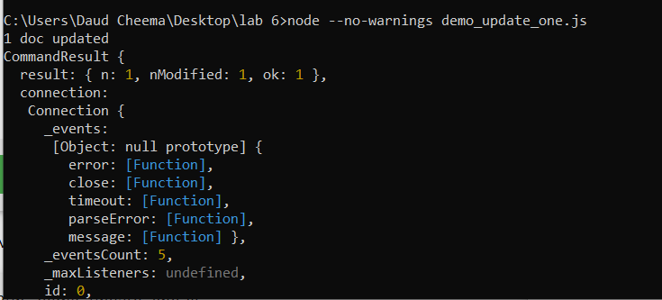

**Task 14:**

var mc = require("mongodb").MongoClient;

var url = "mongodb://localhost:27017/";

mc.connect(url, { useNewUrlParser:true }, function(err, db){

if(err) throw err;

var dbo = db.db("mydb");

dbo.collection("customers").find({}, { projection: {_id : 0, name:1, address:1}}).limit(5).toArray(function(err, result){

if(err) throw err;

console.log(result);

db.close();

});

});

**Output:**

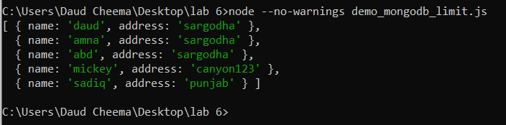

**Task 15:**

var mc = require("mongodb").MongoClient;

var url = "mongodb://localhost:27017/";

mc.connect(url, { useNewUrlParser:true }, function(err, db){

if(err) throw err;

var dbo = db.db("mydb");

var query = {address:"india"};

var newVal = {$set:{name:"mickey", address:"canyon123"}};

dbo.collection("products").aggregate([

{$lookup:{

from: 'details',

localField: '_id',

foreignField: '_id',

as: "productsdetails"

}

}

]).toArray(function(err,res) {

if (err) throw err;

console.log(JSON.stringify(res));

db.close();

});

});

**Output:**

